VEX V5 Override: Session 5

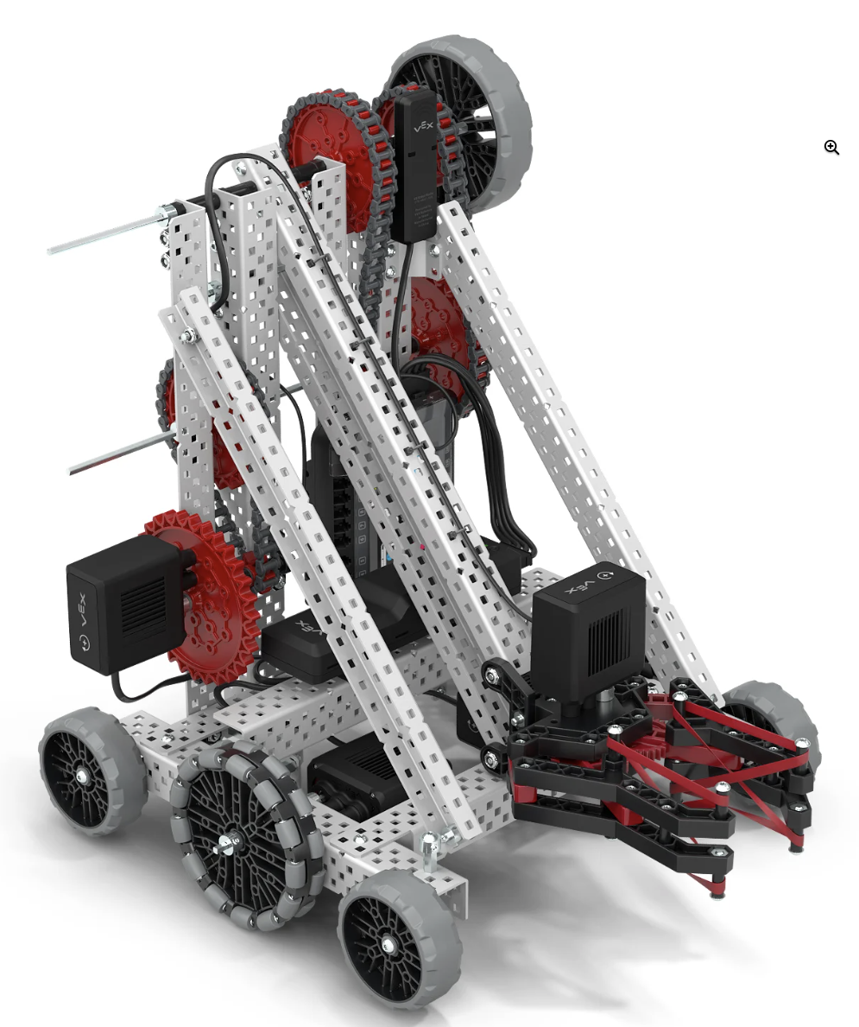
Activity: Make an improvement to Flex!

Collaborate with your team to make a small improvement to Flex’s design.
- Think about a small improvement your team could make to Flex that could allow you to score points more easily. Sketch your design in your engineering notebook. Make notes explaining why the improvement is needed and how it will help.
- Come together for a collaborative team meeting. In this meeting:
  - Everyone should share their improvement idea, and back it up with notebook documentation.
  - Decide as a team which modification you will try first.
  - Decide how you will test if that modification is effective.
  - Decide who will make the adjustments to the robot, who will drive the robot during testing, and who will collect data on the test.
- Make and test the modifications, and collect data in the engineering notebook.
- Come together to discuss the results of the modification, and decide on whether to keep it, or try again.
Example Documentation:
Modification | Test # | Time to Complete | Notes
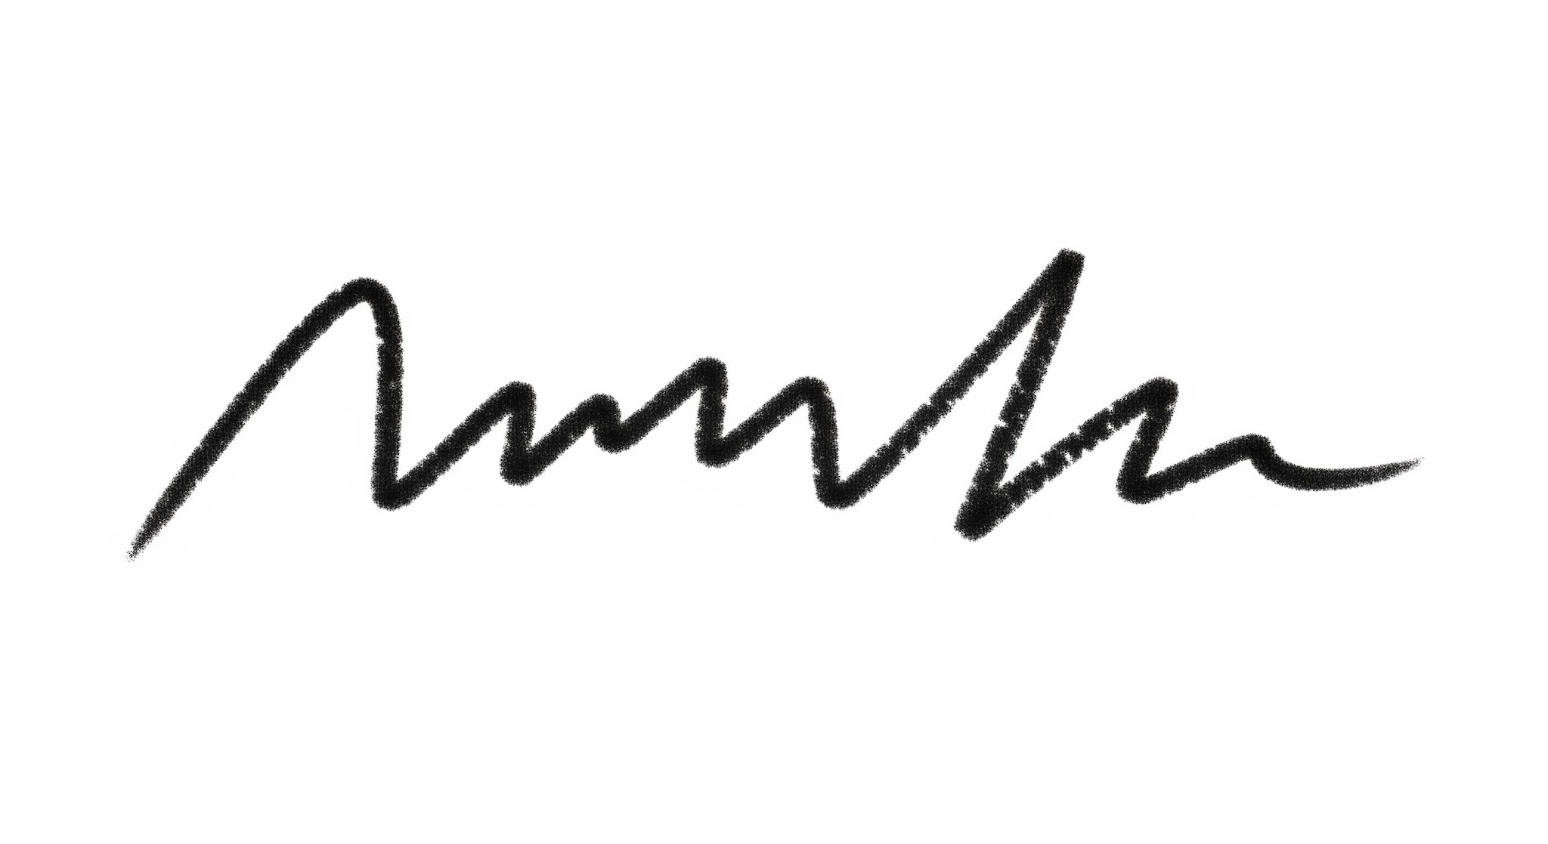 | 1 | 12 seconds | This helped by….
Feeling Stuck?
- Focus on one small change at a time, and use what you learn from that change to move forward!

Discussion Questions  - Based on the data you collected, how did the modification affect the robot’s performance?  - What did you learn from that modification?  - What do you think your next improvement should be? What ideas do you have? | Activity Checklist  - All team members suggested and shared improvement ideas.  - The team reached consensus about the improvement to try.  - The improvement was made and tested.  - Data was collected in the engineering notebook.  - The team discussed the data and decided whether to keep the modification or try again.

